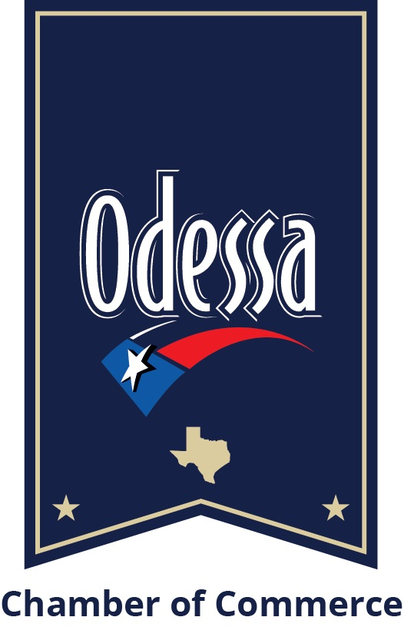
*Please note: Some months will have more available dates than others due to
holidays or Chamber closings.

E-Blast Dates (2020-2021)
Please circle desired date(s)

October 2020 | November 2020 | December 2020 | January 2021 | February 2021 | March 2021
1st 6th 7th 8th  13th 14th 15th  20th 21st 22nd  27th 28th 29th | 3rd 4th 5th 10th  11th 12th 17th  18th 19th 24th  25th 26th | 1st 2nd 3rd  8th 9th 10th  15th 16th 17th  22nd 23rd 24th  29th 30th 31st | 5th 6th 7th  12th 13th 14th  19th 20th 21st  26th 27th 28th | 2nd 3rd 4th 9th  10th 11th 16th  17th 18th 23rd  24th 25th | 2nd 3rd 4th 9th  10th 11th 16th  17th 18th 23rd  24th 25th 30th  31st

April 2021 | May 2021 | June 2021 | July 2021 | August 2021 | September 2021
1st 6th 7th 8th  13th 14th 15th  20th 21st 22nd  27th 28th 29th | 4th 5th 6th 11th  12th 13th 18th  19th 20th 25th  26th 27th | 1st 2nd 3rd 8th  9th 10th 15th  16th 17th 22nd  23rd 24th 29th  30th | 1st 6th 7th 8th  13th 14th 15th  20th 21st 22nd  27th 28th 29th | 3rd 4th 5th 10th  11th 12th 17th  18th 19th 24th  25th 26th 31st | 1st 2nd 7th 8th  9th 14th 15th  16th 21st 22nd  23rd 28th 29th  30th

Purchaser Member Information

Business Name: Contact:

Email: E-Blast date(s):

Please indicate the preferred email blast date from the production schedule above. The Chamber will confirm if the date(s) are available before processing. E-Blast is due to the Chamber one week prior to the scheduled send date, see E-Blast guidelines form for specs and sizing information.

Payment Information - please check E-Blast option

___Single E-Blast - $250 ___Three E-Blasts - $600

Payment type: ___Cash ___Check ___Credit Card ___Invoice

Name on card: Phone number:

Card number: Exp. Date: CVC:

Billing Address:

Please send completed form to carlah@odessachamber.com with E-Blast Advertising in the subject line. For additional questions, contact Carla Hartwig at 432-333-7864.

