Thank you for your continued support of the Odessa Chamber of Commerce. The
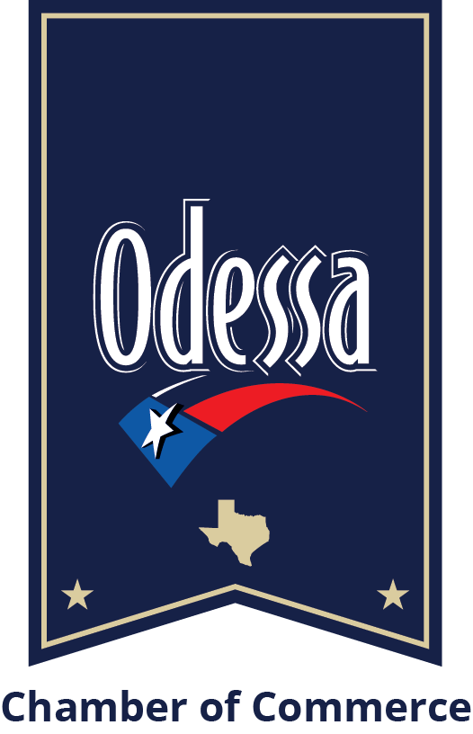
Odessa Chamber of Commerce offers E-Blast advertising to active Chamber members.

E-Blasts will be sent to our entire membership base, including past and current Leadership Odessa participants, the Young Professionals of Odessa membership base and our other newsletter subscribers, totaling a reach of 2,000 people.

General Information
- E-Blasts are sent three times a week on Tuesday, Wednesdays and Thursdays.
- Advanced payment is required to secure an email blast.
- Acceptable forms of payment are cash, credit card and checks. Checks should be made payable to the Odessa Chamber of Commerce with “Chambertising” in the memo section.
- Invoicing is an available option.
- Content is at the Chamber’s discretion and subject to Chamber approval. The Chamber has the right to refuse any advertising not consistent with the Chamber’s mission.

Pricing
- (1) Email blast: - $250
- (3) Email blasts: - $600
*Limit one per month depending on availability

Deadlines
- Ad copy must be received for Chamber processing at least one week prior to the scheduled blast date.
- Refunds and rescheduling will not be warranted due to high demand.
- Advertisers must approve the layout and content before the close of the business day the day before the email blast is sent out. If final approval is not received, the E-Blast will be sent as is, and the Chamber will not be responsible for any errors.

Email Specs and Format
- The E-Blast should be in a pdf format with artwork included. In addition to the artwork, if there is a URL or a website associated, the Chamber will include this in the email if requested.
- Our software for email blasting is Constant Contact. Its standard template width is 600 pixels. Please note that images wider than 600 pixels may cause the template to display incorrectly.
- Best quality for E-blast is in PDF format.
- Please refer to us for additional questions on specs.

Please send completed form to samanthac@odessachamber.com with E-Blast Advertising in the subject line. For additional questions, contact Samantha Cypert at 432-333-7863.

